Muscles
There are three types of muscle within the human body:
Skeletal Muscle (voluntary muscle)
These are the muscles which are attached to our skeletons and cause us to move our body parts. They are called voluntary muscles as they are under our control. They are sometimes also called striated as they have a stripy appearance!
Smooth Muscle (involuntary muscle)
This muscle is not under our direct control and contracts of its own accord. It is situated in the walls of many of our organs, such as the stomach and blood vessels. It is called smooth as it does not share the same stripy appearance as skeletal muscle.
Cardiac Muscle
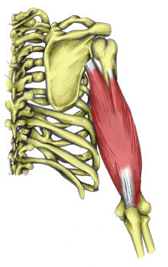
As the name suggests, this muscle is found in the heart and nowhere else. It is a specialised type of muscle which works continuously and is not under our control.

Muscle Fibres
Muscles are made of bundles of fibres. These can be either Fast Twitch or Slow Twitch
Fast twitch fibres are used for powerful, fast movements. This however means they get tired quickly. Athletes who are good at short evemts which require speed and power will have a higher number of fast twitch fibres
Slow twitch fibres are good for endurance activities. They contract slowly with less force, but do not tire so easily. Long distance runners tend to have more of these fibres.
Everyone has a similar number of muscle fibres. People with larger muscles have larger fibres, not more of them.

Muscle Pairs
In order for a muscle to cause a movement, it crosses a joint. It is attached to two bones which form the joint by tendons. Just one of these bones will move when the muscle contracts. For example, when the quadriceps muscles contract, the Tibia of the lower leg is pulled forwards to straighten the knee.
Muscles have two ends, one is called the origin, and is the end that attches to the stationary bone (in the example of the quadriceps - the end attaching to the Femur). The other end is called the Insertion and is attached to the moving bone (the Tibia).
Because muscles only pull, they cannot push, they work in pairs. These pairs are called antagonistic pairs. As one muscle contracts (shortens), the other relaxes (lengthens). The muscle which is contracting is called the agonist, or prime mover. The relaxing muscle is called the antagonist. There is a thrid muscle type within this model, called a synergist. These muscles help to stabilise the bone which isn't moving.
For example - when performing a bicep curl:
Agonist - Biceps Brachii
Antagonist - Triceps Brachii
Synergist - Deltoid

Muscle Contractions
Muscles can contract in two different ways:
Isometric - the muscle length does not change and there is no movement. For example when you are carrying a bucket of water
Isotonic - the muscle length changes, causing movement at a joint. For example a bicep curl

Performing exercises and being active in our daily life can cause our muscles to get stronger. As already mentioned, strong people have larger muscle fibres. This growth in muscle size is called hypertrophy.
If we do not use our muscles regularly, the opposite can happen and the muscles reduce in size. This is called atrophy.
Muscles are always slightly under tension, to enable us to hold a position, such as sitting upright. This small amount of muscle tension, is known as muscle tone. Exercise improves muscle tone.

Skeletal Muscle Cell Structure

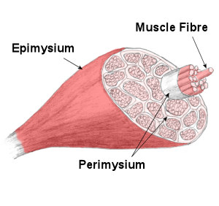
Although skeletal muscle cells come in different shapes and sizes the main structure of a skeletal muscle cell remains the same.

Muscle Anatomy
If you were to take one whole muscle and cut through it, you would find the muscle is covered in a layer of connective muscle tissue known as the Epimysium. The Epimysium protects the muscle from friction against other muscles and bones.
<!--
google_ad_client = "pub-8908006911624355";
/* 336x280, Anatomy */
google_ad_slot = "8629560228";
google_ad_width = 336;
google_ad_height = 280;
//-->It also continues at the end of the muscle to form (along with other connective tissues) the muscles tendon. Looking at the cross section of the muscle you can see bundles of fibres / fibers, known as Fasciculi, which are surrounded by another connective tissue, called the Perimysium. Each Fasciculi contains anywhere between 10 and 100 muscle fibres, depending on the muscle in question.

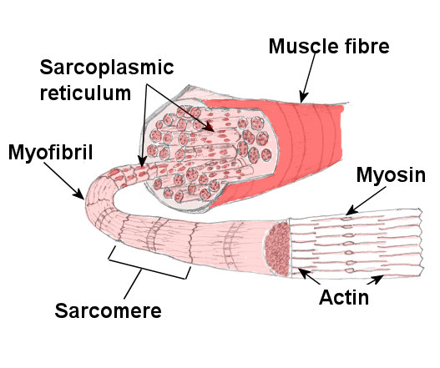
A large strong muscle, such as thoses forming your Quadriceps would have a large number of fibers within each bundle. A smaller muscle used for precision movement, such as those in the hand would contain far fewer fibres per Fasciculi.
Looking at each muscle fiber in detail, you can see they too are covered in a fibrous connective tissue, known as Endomysium which insulates each muscle fiber. Muscle fibers can range from 10 to 80 micrometers in diameter and may be up to 35cm long.
Beneath the Endomysium and surrounding the muscle fibre is the Sarcolemma which is the fibres cell membrane and beneath this is the Sarcoplasm, which is the cells cytoplasm, a gelatinous fluid which fills most cells.
This contains Glycogen and Fats for energy and also Mitochondria which are the cells powerhouses, inside which the cells energy is produced.
Each muscle fiber itself contains cylindrical organelles known as Myofibrils. Each muscle fiber contains hundreds to thousands of Myofibrils. These are bundles of Actin and Myosin proteins which run the length of the muscle fiber and are important in muscle contraction.
Surrounding the Myofibril there is a network of tubules and channels called the Sarcoplasmic Reticulum in which Calcium is stored which is important in muscle contraction. Transverse tubules pass inwards from the Sacrolemma throughout the Myofibril, through which nerve impulses travel.
Each Myofibril can then be broken down into functional repeating segments called Sarcomeres. For more information on sacomeres and how muscles contract take a look at sliding filament theory.

