Modern Sports

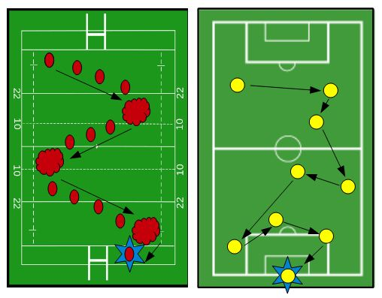

BE ABLE TO CHOOSE
RUGBY OR FOOTBALL

Name:  Surname: Class: | Mark:
Comments: | Mark:
Team Sport

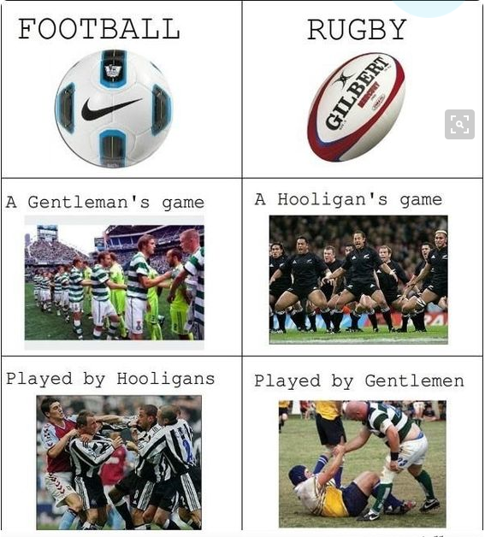

How much do you know about the 2 games ?
With your partner file the table then Walk around the class and talk to other students. Change partners often. Sit with your first partner(s) and share your findings.

Soccer | Rugby

FOOTBALL (SOCCER) DISCUSSION

STUDENT A’s QUESTIONS (Do not show these to student B)
1) | Why do you think football is the world’s most popular sport?
2) | Do you think professional footballers get paid too much?
3) | Is there anything else that joins the world in celebration like the football World Cup?
4) | In 30 seconds, can you explain what football is?
5) | Do you think women’s football is as exciting as men’s?
6) | Where is the world’s best football played?
7) | What do you like and dislike about football?
8) | What do you know about the history of football?
9) | ‘Football’ or ‘soccer’ - Which word is best?
10) | Ronaldo or Messi – Who is better?
---------------------------------------------------------------------------

RUGBY DISCUSSION
STUDENT B’s QUESTIONS (Do not show these to student A)
1) | In 30 seconds, can you explain what rugby is?
2) | Do you think Rugby is brutal? Why ? Explain…
3) | Can you name some rugby rules?
4) | Do you think that rugby will as much popular as Football? Why?
5) | Where is the world’s best Rugby played?
6) | What do you understand by the term ‘Rugby widow’?
7) | Do you think Rugby is a game made for girls?
8) | What are the different championships in the world?
9) | What do you like and dislike about rugby?
10) | Do you think rugby will be different 50 or 100 years from now?

Soccer - the world's most exciting sport

SPORT: In pairs / groups, brainstorm a list of the most exciting sports in the world. Which ones are the best? What makes them the best? What improvements would you make to them? Are they played by most of the world’s countries? If not, why not?

1. TRUE / FALSE: Look at the article’s headline and guess whether these sentences are true (T) or false (F):
a. | American scientists say English soccer is more exciting than US sport. | T / F
b. | The scientists looked at over 300,000 games across five sports. | T / F
c. | Their model was based on upsets being a measure of excitement. | T / F
d. | English soccer matches produced far fewer upsets than other sports. | T / F
e. | The survey is grim reading for aficionados of American sports. | T / F
f. | There is increasingly less parity among teams in English soccer. | T / F
g. | Basketball has overtaken soccer in being the most exciting sport. | T / F
h. | The survey factored in the fever that comes from soccer’s World Cups. | T / F

2. SYNONYM MATCH: Match the following synonyms from the article:
a. | statistical | considerably
b. | scrutinized | little guy
c. | proposed | buffs
d. | underdog | examined
e. | number crunching | put forward
f. | grim | balance
g. | aficionados | numerical
h. | parity | excluded
i. | markedly | gloomy
j. | omitted | analysis

Soccer - the world's most exciting sport
English soccer is more exciting than ________ of the top American team sports – that’s according to the statistical research of US scientists. Eli Ben-Naim of the Los Alamos National Laboratory and his ________ analyzed the results of 301,657 games of soccer, baseball, hockey, basketball and American football played since 1888. They ________ the predictability of results and proposed “the likelihood of ________ as a measure of competitiveness”. They said: “We introduce a ________ model in which the ________ team wins with a fixed upset probability.” Their number ________ found that soccer matches in England’s top league are more likely to ________ upsets, with the underdog winning, than matches in America’s major league sports. |  | scrutinized  colleagues  crunching  mathematical  any  produce  upsets  underdog
The survey is not all ________ reading for ________ of American sports. It seems that soccer has become less exciting and more predictable over the past fifty years. This suggests that there is less ________ in the English league and the potential for upsets is ________. On average, the underdog wins 45 percent of the time in soccer, although this figure has markedly fallen in the past decade. In contrast, the ________ of upsets in baseball is increasing. The results show that baseball has already ________ soccer to become the more exciting of the sports. Rugby, cricket and other team sports were ________ from the survey because they do not have a big following in the US. The survey also failed to account for the soccer fever that will ________ the world with this year’s month-long soccerfest – the World Cup Finals. |  | frequency  omitted  aficionados  lessening  grip  grim  surpassed  parity

DISCUSSION

STUDENT A’s QUESTIONS (Do not show these to student B)
- Did the headline make you want to read the article?
- Do you like soccer?
- Where is the world’s best soccer league?
- Do you prefer the word “soccer” or “football”?
- Why do you think American football is called “football” when it’s largely played with the hands?
- What do you think is the most exciting sport in the world?
- Do you prefer individual or team sports?
- What elements of sport excite you the most?
- Do you get upset when your favorite team or star is upset?
- Do you always root for the underdog?

STUDENT B’s QUESTIONS (Do not show these to student A)
- Did you like reading this article?
- What do you think about what you read?
- Do you agree with the survey’s findings?
- Why do you think baseball and American football are not played in anywhere near as many countries as soccer?
- Do you think the relatively low scoring games in soccer makes it a boring sport?
- Who do you think is more famous worldwide, soccer’s Pele or baseball’s Babe Ruth?
- Who do you think is the most famous sports star ever?
- Are you more passionate about your favorite local team or your national team?
- The soccer World Cup is the planet’s most watched televised event. Does this make soccer the best sport in the world?
- Did you like this discussion?

SPEAKING
SPORT: In pairs / groups, agree on a score of 1 to 10 for the points in the top row. A score of “1” means no excitement, beauty, etc; a score of “10” is perfection.
SPORT | EXCITEMENT | BEAUTY | ATHLETICISM | UPSET POTENTIAL
Soccer
Basketball
Sumo
Golf
F1 motor racing
Other
____________
Change partners and talk about the scores you agreed on with your old partner(s).
Talk about the reasons for any differences in your scores.

HOME WORK - MY SPORT: Make a poster about your favorite sport. Explain why you like it and what makes it so exciting. Show your poster to your classmates in the next lesson.
RUGBY FOOTBALL UNION - R.F.U

WARM UP :
Rugby: Spend one minute writing down all of the different informations from the video about the history of Rugby. Share your words with your partner(s) and talk about them. Together, try to recap the history of rugby.

Rugby for beginners

Watch the video and collect informations

https://www.youtube.com/watch?v=FOJejnPI0p0&t=9s

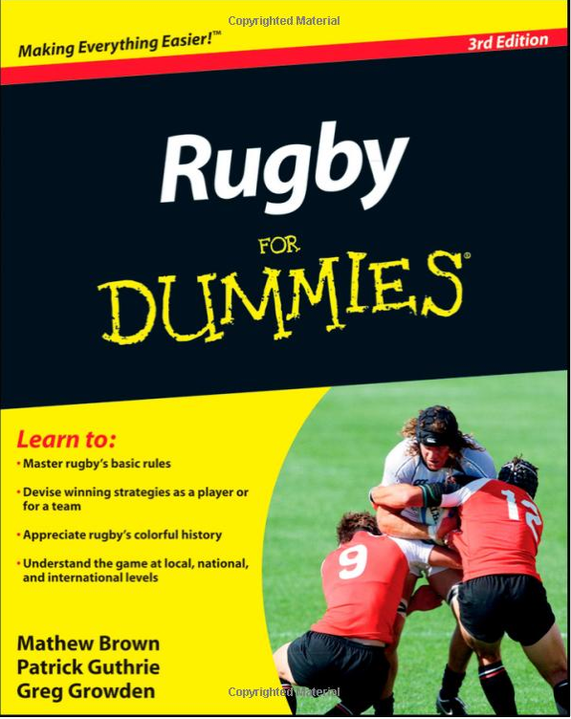

Rugby is beautiful

https://www.youtube.com/watch?v=R2f_jsAK-_k

Find 5 words which express your feelings about this movie. You may use your phone or any dictonary. Share your words with your partner. Explain your choises.

Rugby Student A

Rugby is a sport that has (1) _________________ of fans around the world, even though there are some countries in which it is hardly played at all. The old saying that rugby is ‘a ruffian’s game played by gentlemen’ was always partly a joke but it does indicate two things: first that rugby is a (3) _______________ _____________________________ game (although it can also be beautiful and spectacular), and second that it was developed in an ‘upper class’ environment. Indeed, its name comes from the fact that it is said to have been invented on the
(5) ______________________________, an exclusive private school in England, in the 1820s. There are now (7) ______ main forms of rugby, the more widespread of which is played by two teams of fifteen players on a grass pitch about (9) _____ metres long and 70 metres wide.
It’s probably fair to say that the rules are more complicated than those of football and that someone watching it for the first time might sometimes find it difficult to understand (11) ________________________. The basic idea, however, is for each team to move the oval-shaped ball towards the end of the pitch defended by their opponents. The players can (13) _______________ ___________________ as well as kicking it (although they can only throw it backwards or sideways, not forwards), and when a player is carrying the ball forwards the opposing players are allowed to stop him by pulling him to the ground.
There are different ways to score points but the highest number ((15) ______) is for a ‘try’, which is when an attacking player manages to get through the defending players to put the ball down on the ground behind the line at the end of the pitch. As with football and cricket, rugby spread around the world in the nineteenth century with the expansion of the British Empire. The game is popular in the ex-British colonies of (17) _____________________________________ – three countries whose national teams are always among the best in the world. Not all the major rugby nations are English-speaking, though: France are one of the best teams and Argentina – better known for football, of course – have also been doing well.
Like football, rugby has a World Cup competition that takes place every four years. The last one was in 2015, in England, when the champions were South Africa, who beat (19) __________ 15-6 in the final. The next World Cup will be in Japan in 2019, when the home team – known as the ‘All Blacks’ because of their black shirts, shorts and socks – will probably be the favourites.

Write questions to find out the missing information in the text

1. How many _________________________________________________________ ?
3. What kind ________________________________________________________ ?
5. Where _____________________________________________________________ ?
7. How many ________________________________________________________ ?
9. About how ________________________________________________________ ?
11. What _____________________________________________________________ ?
13. What _____________________________________________________________ ?
15. How many ________________________________________________________ ?
17. Whose ____________________________________________________________ ?
19. Who _____________________________________________________________ ?
Rugby Student B

Rugby is a sport that has many millions of fans around the world, even though there are some countries in which it is hardly played at all. The old saying that rugby is ‘(2) ______________________________________’ was always partly a joke but it does indicate two things: first that rugby is a physically tough and occasionally violent game (although it can also be beautiful and spectacular), and second that it was developed in an (4) _____________ environment. Indeed, its name comes from the fact that it is said to have been invented on the playing fields of Rugby school, an exclusive private school in England, in (6) ______. There are now two main forms of rugby, the more widespread of which is played by two teams of (8) __________ players on a grass pitch about 100 metres long and
(10) _____ metres wide. It’s probably fair to say that the rules are more complicated than those of football and that someone watching it for the first time might sometimes find it difficult to understand what’s going on. The basic idea, however, is for each team to move the (12) _______-shaped ball towards the end of the pitch defended by their opponents. The players can pick up, carry and throw the ball as well as kicking it (although they can only throw it backwards or sideways, not forwards), and when a player is carrying the ball forwards the opposing players are allowed to stop him by (14) __________________________. There are different ways to score points but the highest number (five) is for a ‘try’, which is when an attacking player manages to get through the defending players to put the ball (16) _________________________ behind the line at the end of the pitch. As with football and cricket, rugby spread around the world in the nineteenth century with the expansion of the British Empire. The game is popular in the ex-British colonies of Australia, New Zealand and South Africa – three countries whose national teams are always among the best in the world. Not all the major rugby nations are English-speaking, though: France are one of the best teams and Argentina – better known for football, of course – have also been doing well. Like football, rugby has a (18) ________________________ that takes place every four years. The last one was in 2007, in France, when the champions were South Africa, who beat England 15-6 in the final. The next World Cup will be in New Zealand in 2011, when the home team – known as the ‘All Blacks’ because of (20) __________________________________ – will probably be the favourites.

Write questions to find out the missing information in the text

2. What is ____________________________________________________________ ?
4. What kind __________________________________________________________ ?
6. When _____________________________________________________________ ?
8. How many ________________________________________________________ ?
10. About how _______________________________________________________ ?
12. What _____________________________________________________________ ?
14. How _____________________________________________________________ ?
16. Where ____________________________________________________________ ?
18. What _____________________________________________________________ ?
20. Why _____________________________________________________________ ?

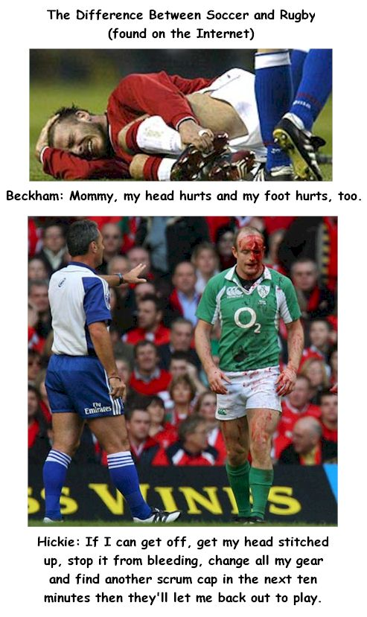

FOOTBALL VS RUGBY

1. SPORT: In pairs, brainstorm Rugby and Football. Which ones is the best? What improvements would you make to them? Are they played by most of the world’s countries? If not, why not?
rugby commercial
https://www.youtube.com/watch?v=CSFx4g61djM

TWO-MINUTE SPORT DEBATES: Face you partner. Take part in the following for-fun debates. Partner A strongly believes in the first argument.
- Soccer is more exciting. vs. Rugby is. It has higher scores.
- Sumo is infinitely cooler than wrestling. vs. Sumo is fat guys falling over.
- Skiing is better to watch than skating. vs. Skating is a lot more engrossing.
- F1 is a million times more thrilling than horse racing. vs. Horse racing is best.
- Men’s sport beats women’s every time. vs. Many women’s sports are better.
- Golf is the world’s dullest sport. vs. A 5-day game of cricket is the most boring.
- The Olympics is the best sports event. vs. You cannot beat soccer’s World Cup.
- Drugs should be used to make sport better. vs. Drugs have no place in sport.

https://www.youtube.com/watch?v=toqLPqeQ2DE

Debate : Rugby vs Foot Ball

Which is the best sport ? In pair work find different arguments pro or con Rugby or foot ball.

LESSON Two:

AUDIO LESSON

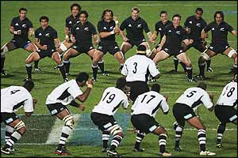

- Warm up (video haka)
- Listening test
- Quizz
- What do you know about the Blacks

Todd: OK, Leonard, you're from New Zealand.
Leo: Yes. Yes.
Todd: So we're going to talk about your country's national pastime.
Leo: Oh, that would be Rugby.
Todd: OK.
Leo: Uh, the All Blacks is well known around the world, especially here in Japan.
Todd: Uh-huh.
Leo: Especially if you talk to nearly any Japanese, they'll know the word All Black.
Todd: Yeah.
Leo: It's actually the World Cup, uh, this year, in October.
Todd: Really, where, where is the World Cup?
Leo: It's actually held in Australia.
Todd: Oh, really!
Leo: And around, around, mainly around Sydney.
Todd: OK.
Leo: And right now is the rugby Tri-Nation Cup, which is a match between New Zealand, Australia, and South Africa.
Todd: OK. Do you play rugby?
Leo: I don't play rugby. I played rugby in school, but I actually play soccer.
Todd: Oh, really! OK. So you're kind of a, an anomoly?
Leo: Yes, yes, yes! I do support the team, and I like to watch all the games.
Todd: Uh-huh!
Leo: And I have a lot of friends here in Japan, and we get together just to watch the game. There's actually a game this Saturday. New Zealand against Australia, which is a big one.
Todd: Are you going to watch he game?
Leo: Oh, Yes! Definitely!
Todd: All right! Well, go, go All Blacks.Leo: That's right.
Todd: OK. Great. Thanks a lot Leonard.
1) What is well know about New Zealand?
a) The All Blacks
b) The soccer team
c) The weather
2) When is the World Cup?
a) June
b) May
c) October
3) What country is in the Tri-Nation Cup?
a) Japan
b) England
c) South Africa
4) What sport does Leonard like?
a) Soccer
b) Rugby
c) Tennis
5) What does Leo say he is going to do this Saturday?
a) Watch soccer
b) Watch rugby
c) Play Soccer
http://www.elllo.org/Text0201/210-Leo-Rugby.htm

Team work with documents on NewZealand (7 texts)

Marks :

Marks :

Marks :

Marks :

Marks :

LESSON 3: Video

Work on an advertisement



LESSON 4

SEARCH ON INTERNET

MOTTOS AND EMBLEMS

This is a one hour teamwork in pair group

Research on Internet : (10 min)

You start on google research

- Wordkeys and Websites:

2007 rugby World Cup, Rugby emblems, rugby flags, rugby mottos, IRB...

http://www.answers.com/topic/rugby-world-cup

http://www.wordreference.com

- Task : (20min)

Team work:

Choose a rugby team from the 2007 rugby World cup, get information about this team.
Find the emblem and the motto of this team.

Individual work:

Find information about a famous rugby player who belongs to the rugby team you have chosen.

Present your findings to your classmates.

- Do your own HAKA : (10Min)

Use this web site: http://www.skivedomain.com/sure/laka/

- Valuation:
- One mark for the team work
- One mark for the individual oral performance

Team Work

Individual Work

LESSON FIVE

Training Lesson
(bring your sport gears)

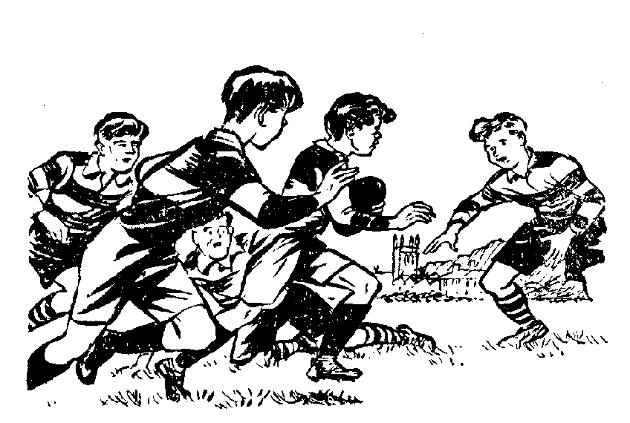

- Warm up (1x1)
- Rugby flag (6X6)

- GLOSSERY

LESSON Six


INTERVIEWING

- Warm up
- Read an Interview
- Conducting an interview
- Reflection and Extension

Warm UP

Work on the interview

Reflection and extension

LESSON SEVEN

Discuss on cartoons



Warm up with the cartoon up there

Choose and present a cartoon

Warm up

Your cartoon :

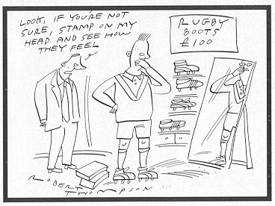

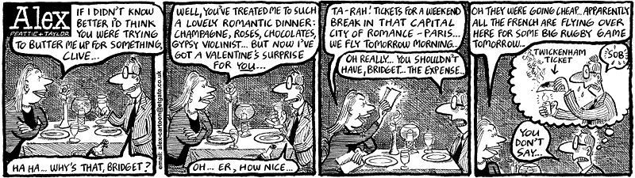




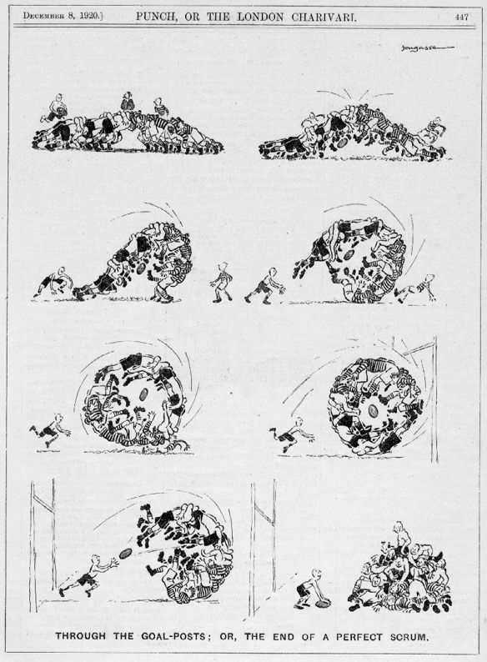

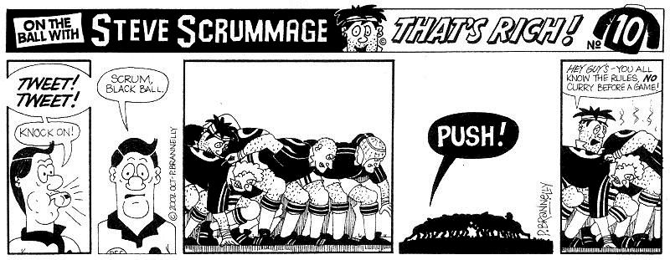

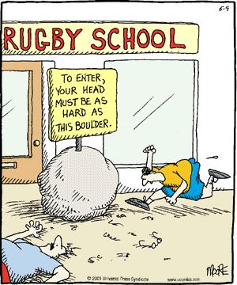

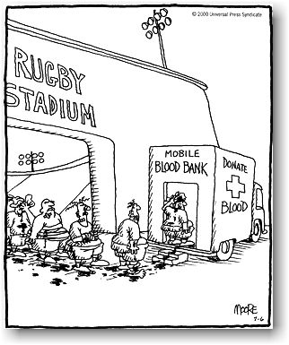



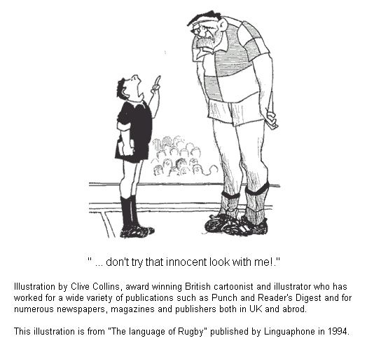

VALUATION

BE ABLE TO INTERVIEW A FAMOUS RUGBY PLAYER
ROLEPLAY IN PAIRWORK

